BC Invaders

Software Requirements Specification

CISC 3140 – Fall 2018

Group 2 Specs

JiaYing Chen

Alex Deng

Rivka Gurkov

Amier Hajyassin

Carol Pignato

Table of Contents

**1. Introduction 2**

1.1 Purpose 2

1.2 Scope 2

1.3 References 2

**2. Overall Description 2**

2.1 General Gameplay 2

2.2 Scoring 3

2.3 Instructions 3

2.4 Level Description 3, 4

**3. User Interface 4**

3.1 Main Menu 4

3.2 Pause Game vs. Quit Game 4

3.3 Game Over Screen 4

**4. System Requirements 4**

4.1 Software Design & Implementation Constraints 4

4.2 Hardware Requirements 5

4.3 Supported Browsers 5

1. Introduction

1.1 Purpose

These specifications were written to describe the BC Invaders game created by Group 2 for the Design and Implementation of Large-Scale Web Applications, CISC 3140 course. The theme of the game is students versus college administration. The objective is to shoot the staff/administration objects in order to acquire points, and completing the final level of the game by defeating the final boss. The player will play the role of a student.

1.2 Project Scope

BC invaders will feature a main menu screen displaying options to view credits, view instructions, view high scores, and start a new game. When the player chooses to start a new game, the game will begin and the player will be able to control the student character and play. When the player reaches game over or wins the game, a prompt will display asking for a name to save with the score to record onto the high scores list. The game will not have save states, and every game will start from level 1.

1.3 References

Below are links you may refer to in order to get a gist of the game.

* [Space Invaders Wiki Info](https://en.wikipedia.org/wiki/Space_Invaders)
* [Space Invaders Game Example](https://youtu.be/kR2fjwr-TzA)

2. Overall Description

2.1 General Gameplay

* The player has 3 lives, and if you are hit by an enemy, you lose 1 life. If you lose all 3 lives, it is game over.
* Staff and administration are enemies.
* Faculty members/professors will cross the battlefield, but you cannot shoot faculty members otherwise you lose a life.
* There will be a heart effect that can regenerate how many lives you have by +1. If you shoot the heart, your lives will regenerate.
* The dean is the final boss. When you defeat the final boss, you win the game.

2.2 Scoring

* +5 points for every administrator killed
* +500 points for killing the dean

2.3 Controls

The user will be able to select main menu options by left clicking on them.

The player will use the following keystrokes to control the character once the game begins:

* Left arrow = move left
* Right arrow = move right
* Spacebar = shoot projectile
* P = pause/resume the game
* ESC = quit game prompt (options are “yes/no”)
  + “yes” will send them back to the Main Menu afterward.
  + “no” will resume the game.

2.4 Level Description

The game will consist of 5 levels, which is basically 5 states for the game.

The whole box of the game should be of a 2D array say like 100 x 100. The player will start off at row 95 and column 50.

For level 1, we have about 50 enemies per row and it will be 2 rows starting at position row 10 covering up to 12. They will be moving up in rows at a certain speed (using a times class) and moving from side to side (meaning changing columns) Each enemy only needs to get shot once to die.

Level 2, same number of enemies and same starting point, 50 enemies, start at row 10, 4 rows, cover up to row 14. The speed as they move up rows will increase by 2. Enemies will shoot more bullets.

Level 3, 50 enemies, start at row 15, 6 rows of enemies, cover up to row 21. Speed as it moves up in rows increases by 4, enemies continue shooting.

Level 4, 50 enemies, start at row 18, 10 rows of enemies, cover up to row position 28. Speed increases by 8 as it moves up in rows and enemies should be shooting more bullets.

Level 5 is the last level and it should start off at row position 20 with 50 enemies per row, and 12 rows of enemies covering up to row position 32. There will be a final boss, the dean at row position 10 shooting at the student rapidly. This boss needs to get shot 20 times in order for it to be defeated. It will not be moving towards the player (in other words, increasing in row and column).

3. User Interfaces

3.1 Main Menu

The main menu should display the game title: “BC Invaders”, followed by four options:

* New Game – begins a new game
* Instructions – displays a screen describing the controls and how to play the game
* Scoreboard – displays a list of all the high scores from highest to lowest
* Credits – displays the credits (names and responsibilities of everyone in Group 2)

3.2 Pause Game vs. Quitting Game

The player should be able to pause at anytime in the game by pressing ‘P’. If the player would rather quit the game, they can press “ESC” which pauses the game **and** displays a prompt asking if they would like to quit followed by “yes” or “no” buttons. If the user selects “yes,” then the game will end and the player will be sent back to the main menu. Note: High scores are not saved if the user quits the game. If the user selects “no”, the game will resume.

3.3 Game Over Screen

The game over screen should be displayed if the player has no lives left. It should display “GAME OVER” followed by the player’s high score for the game and a prompt asking for the player to enter a name to save the high score with. After the player saves their high score, the game goes back to the main menu.

4. System Requirements

4.1 Software Design & Implementation Constraints

BC Invaders is meant to be a client-sided internet browser game, and will be coded in the JavaScript programming language. The animations, window and sounds will be made in and use HTML5/CSS. The play area size should be 600x800 pixels. The high score and other local data will be stored in local browser storage. The game should respond to each user input within 1 second. All code and functions should be fully documented. All program files should include comments regarding authors and dates/times of last modification. The game should not crash or hang unless there is a problem with the OS.

4.2 Hardware Requirements

The game will be running on a web browser on hardware devices such as desktops and laptops. User input will come from mouse clicks and keyboard strokes.

4.3 Supported Browsers

Minimum versions:

* Microsoft Edge v44.17763.1.0
* Google Chrome v70.0.3538.77
* Mozilla Firefox v63.0.1
* Safari v12.0

**Graphics:**

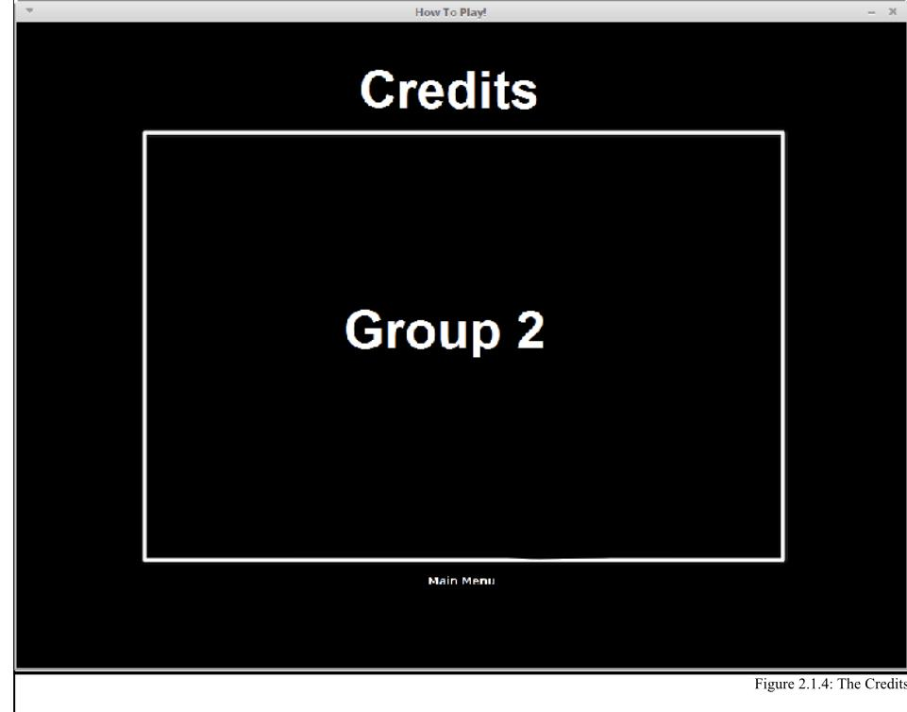

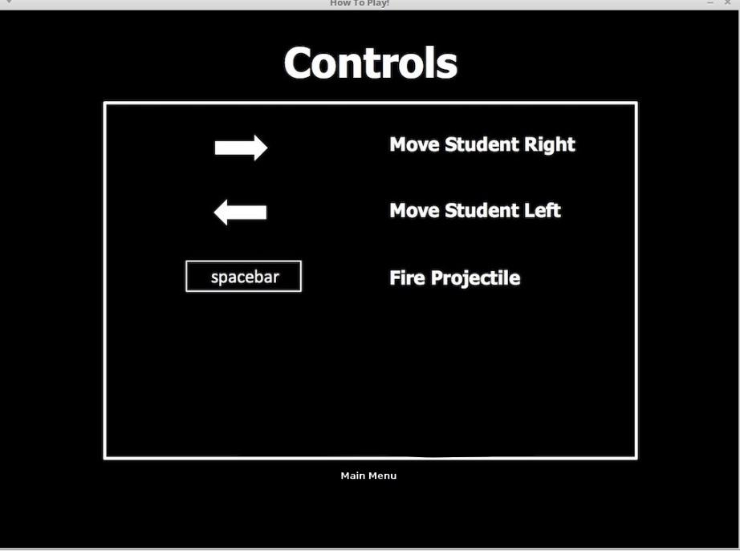

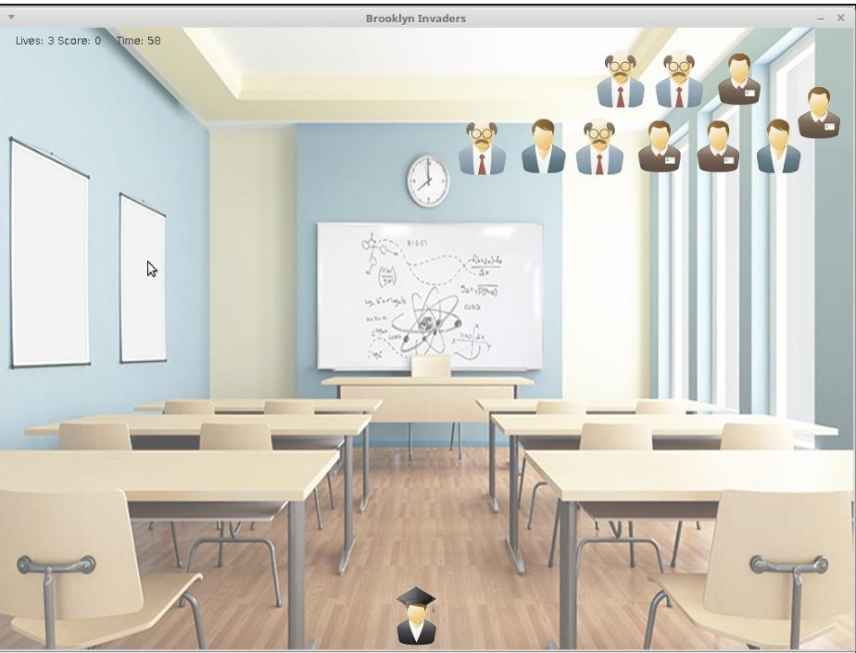

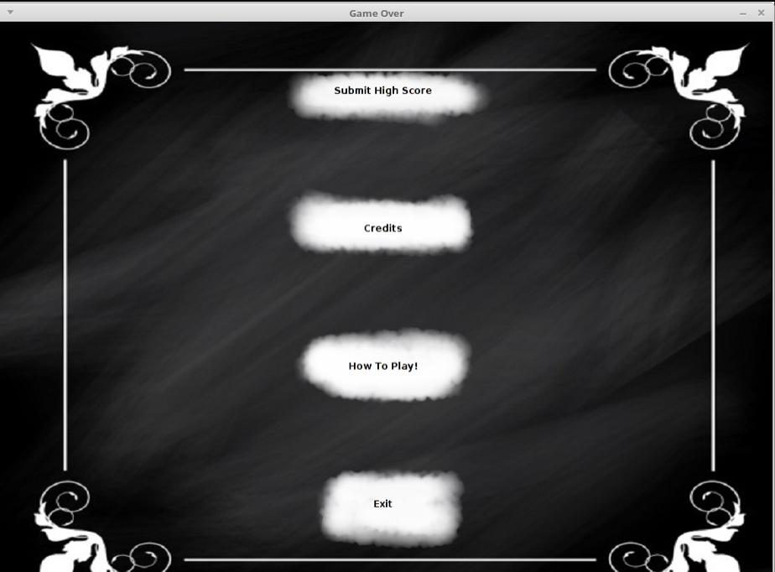

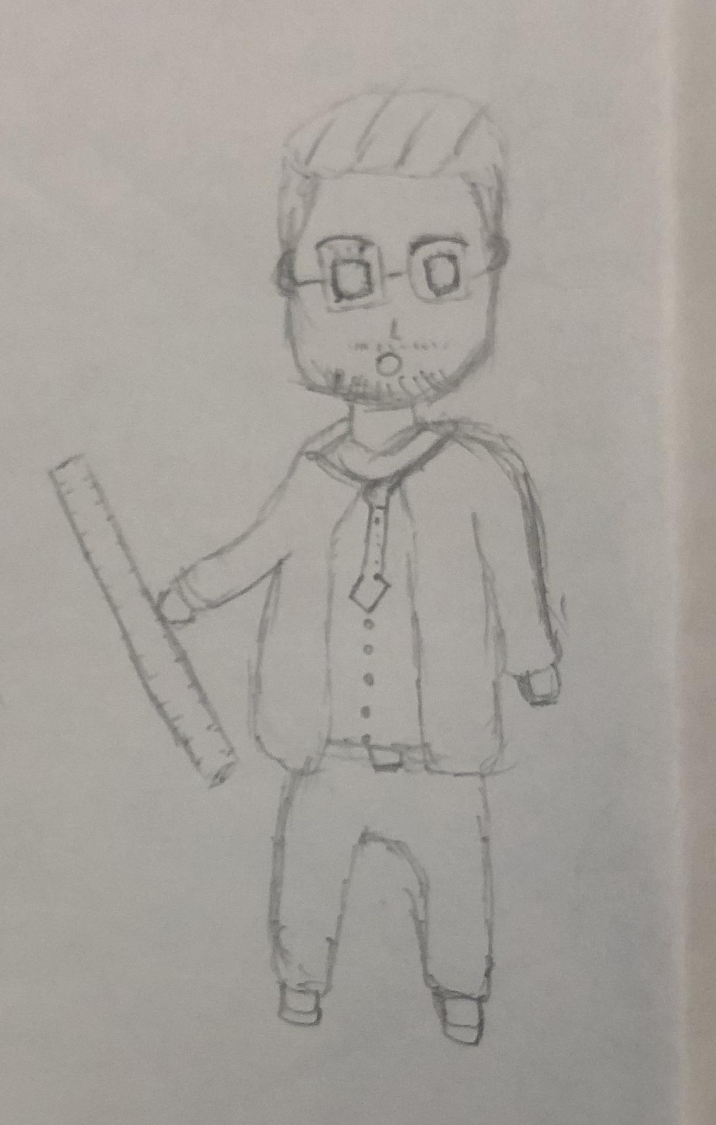

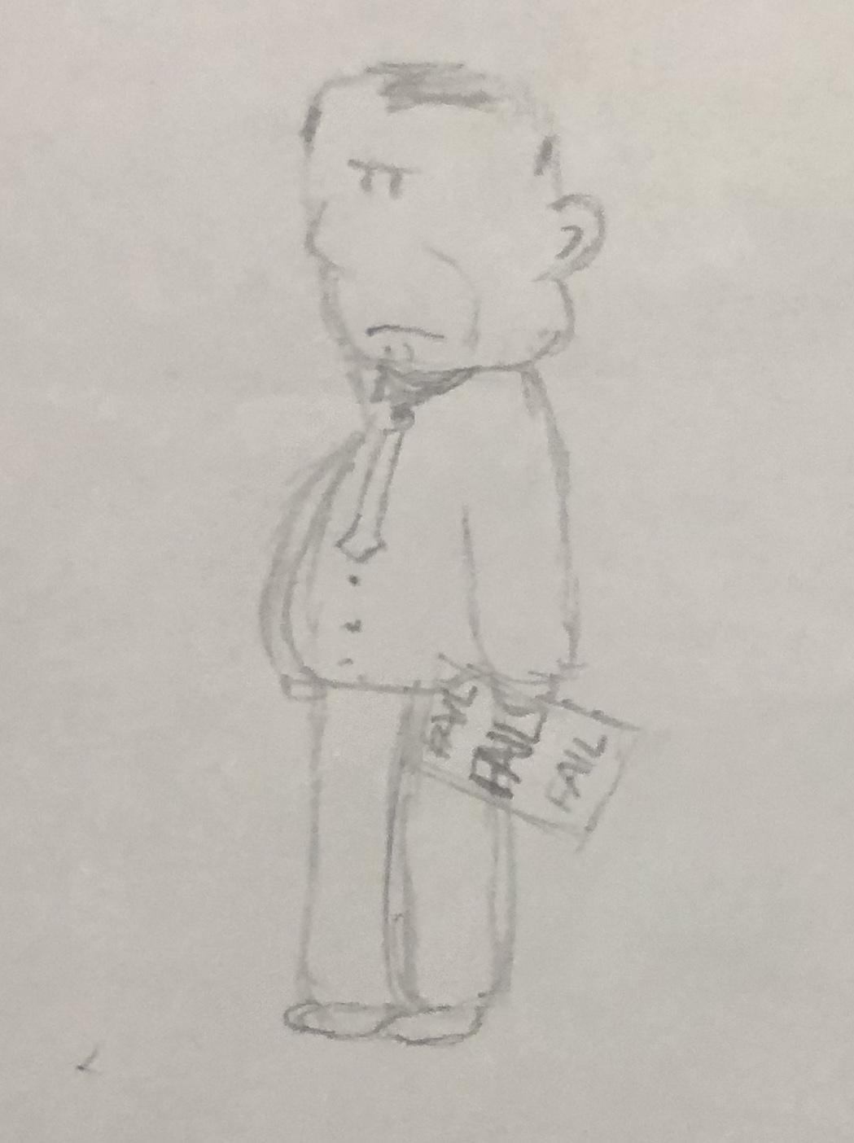

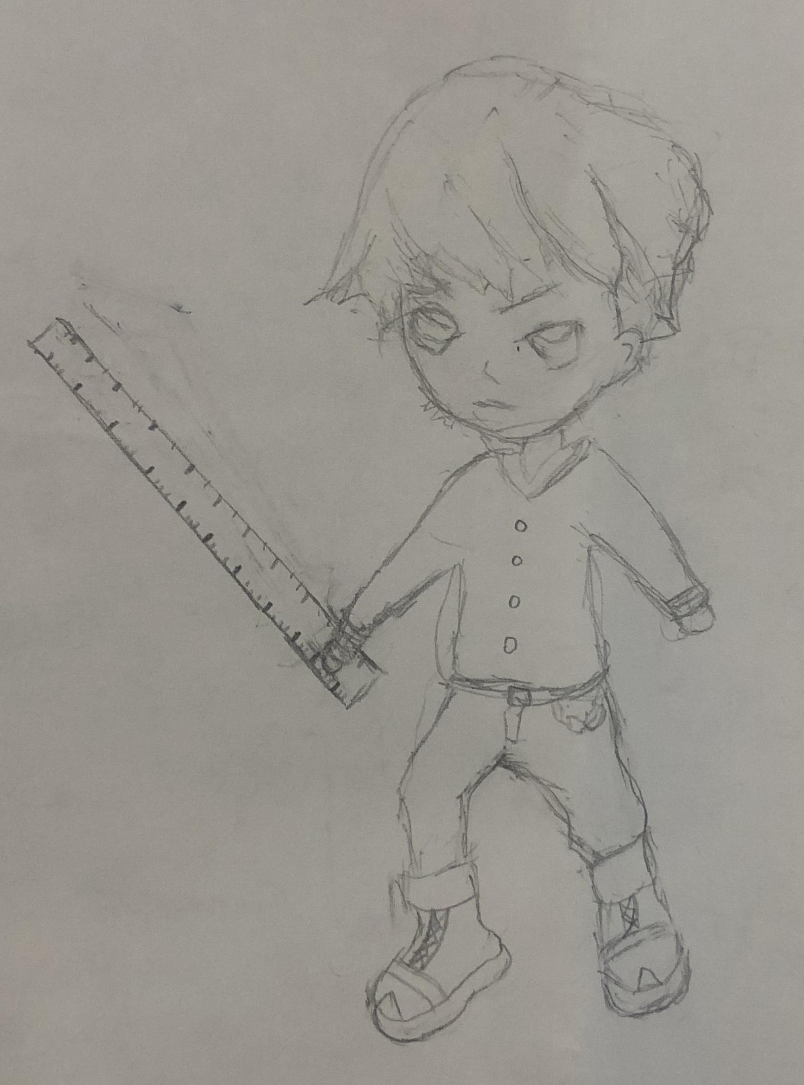

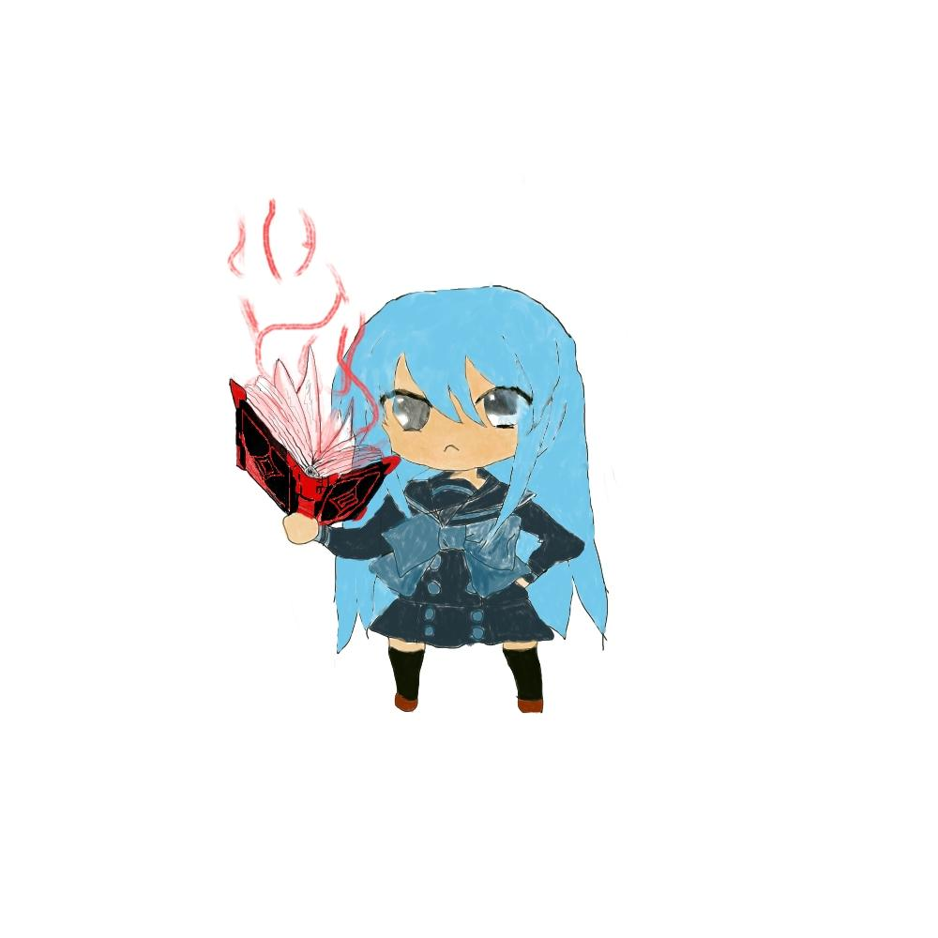



Audio File Format: .wav

Image File Format: .jpg

Video File Format: .mp4

**Shooting sounds**:

<http://soundbible.com/grab.php?id=148&type=mp3>

<http://soundbible.com/grab.php?id=684&type=mp3>

<http://soundbible.com/grab.php?id=640&type=mp3>

**Blowing Up sounds**:

<http://soundbible.com/grab.php?id=1461&type=mp3>

<http://soundbible.com/grab.php?id=696&type=mp3>